
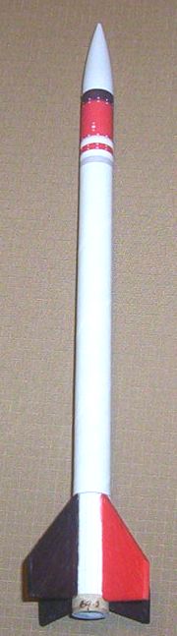
D Region Tomahawk
Sport Scale Flying Model Rocket Kit
Instruction Manual
Kit #K-19
Pratt Hobbies
2513 Iron Forge Road
Herndon, VA 20171
www.pratt-hobbies.com

Parts List:

1 Plastic Nose Cone
1 Cardboard shoulder tube (brown tube with hole on one end)
1 Body Tube (long white tube)
4 Pre-Cut Balsa Fins
1 Aramid Shock Cord (Yellow yarn)
1 Flameproof HeatShield (felt square)
1 Plastic Streamer
1 Thrust Ring (thick cardboard)
2 Launch Lug (small white paper tube)
1 Color Payload Section sticker
1 Fin Wrap Sticker

Read through the instructions completely before you start building!

You will need glue and scissors. We recommend our Rocket Glue. Since all parts are pre-cut, you will not need a knife. You will need a model rocket motor to insert the Thrust Ring (see step 3).

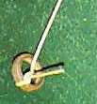
- Unwrap the Aramid Shock Cord. Tie one end around the Thrust Ring as shown. Use an ordinary square knot. Move the knot to the top of the Ring as shown. Secure the knot with a small drop of white glue.
- Thread the free end of the Shock Cord through the Body Tube. Test-fit the Thrust Ring in the bottom of the Body Tube. Insert it with the knot on top.
- Remove the Thrust Ring but don’t pull the Shock Cord all the way out. Run a line of glue around the inside rear of the Body Tube. Don’t worry about getting glue on the Shock Cord. Now insert the Thrust Ring again. Use a model rocket motor to push the Thrust Ring up into the Body Tube, pushing the glue ahead of it. Push the Thrust Ring up until all but ¼ inch of the motor is in the tube. Don’t push the motor all the way in! Remove the motor quickly, and wipe off any glue that might have gotten on the motor.

- Cut out the stickers carefully along their outer edges. Make sure you get the edges straight.
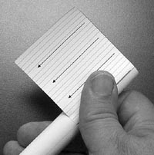
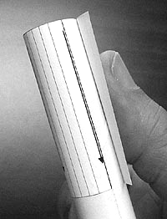
- Without removing the backing paper from the sticky side, wrap the Fin Wrap Sticker around the rear of the Body Tube with the rear edge even with the rear of the tube (the end with the Thrust Ring that you just glued in). Line up the edge of the sticker with the pencil line drawn up the side of the rocket, and make sure the arrows point forward. Curling the sticker around the tube as you test-fit it will help you attach it straight.

- Carefully remove the backing paper from the sticker. Line up the edge with the pencil line and press it down to the tube, just along the edge. Just attach about a quarter inch of the sticker when you start, so you can lift it if you need to straighten it. When it is straight along the pencil line, press it down slowly and carefully all the way around the tube, starting from the center of the edge along the line and working outward. If you work slowly and roll the tube as you go, you won’t get wrinkles in the sticker and it will line up nicely with the edge of the tube.

- Line up one edge of the Color Payload Section Sticker with the pencil line on the tube, even with the front edge of the tube. The brown band goes forward. Attach it the same way you did the Fin Wrap Sticker. The edges of this sticker will overlap.

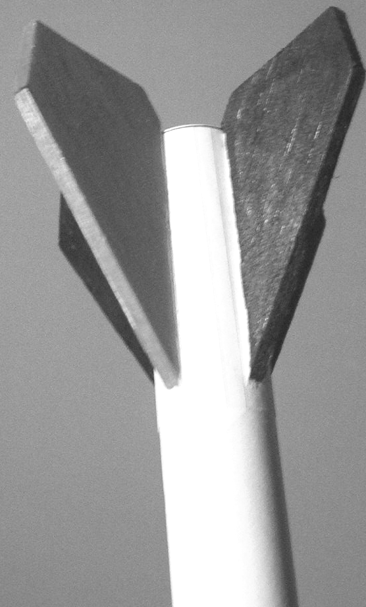
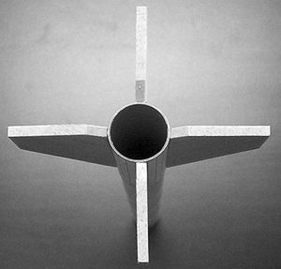
- Run a line of white glue down the root edge of a fin. Make sure the edge is completely covered with glue. Now press the fin in place along the arrow where the edge of the Fin Wrap meets the glue tab. The rear of the fin must be even with the rear of the tube. Wait a minute for the glue to grab.

- When the first fin is firmly attached, glue another fin to the arrow on the opposite side of the tube. Sight down the rear of the rocket to make sure that the two fins are straight across the tube from each other and stand straight out from the tube.

- When the first two fins are dry, glue a third fin to one of the two remaining arrows. Sight from the rear again to make sure the fin is straight. Finally, glue the last fin to the remaining arrow. The fins should form a cross as seen from the rear when they are all in place.

- Test fit the Nose Cone Shoulder Tube in the Nose Cone. It should fit about halfway into the Nose Cone. The hole goes on the outside. Remove the Shoulder Tube, and run a line of glue around the inside of the Nose Cone. Reinsert the Shoulder Tube and wipe away any glue that it pushes up into the Nose Cone.

- Thread the Shock Cord through the hole in the HeatShield, then through the loop in the middle of the Streamer. Tie the Shock Cord to the hole in the Nose Cone Shoulder Tube. The knot should be on the inside of the Shoulder Tube so it doesn’t interfere when the Nose Cone is inserted in the Body Tube. Put a small drop of glue on the knot and tuck the end up into the Nose Cone.
- Lay the HeatShield across the top of the Body Tube and push it down into the tube. The HeatShield needs to completely fill the Body Tube to protect the Streamer from the heat of the rocket motor’s ejection charge. Now fold up the Streamer and insert it in the Body Tube. Finally, coil up the rest of the Shock Cord, put it in the tube, and fit the Nose Cone in place.

- When the glue on the fins is thoroughly dry (at least 15 minutes), form a “fillet” along each fin-body joint. Run a line of glue along the joint and smooth it with your finger. Don’t use a lot of glue; all you want to do is make sure there is glue on both the body tube and the fin, on both sides of the fin.

- Glue one of the launch lugs to the fillet on the right of the fin that is glued to the seam of the Fin Wrap Sticker, along the alignment line. Glue the other Launch Lug to the body tube about halfway up from the bottom, using the pencil alignment line to get it straight with the lower lug. Sight down the tube to make sure the lugs are in line with each other.

- When the glue fillets on the fins are thoroughly dry, the fins can be colored. Sharpie pens or whiteboard markers are good for coloring the fins. Use a sharp pointed or chisel pointed marker to avoid getting color on the fin wrapper or the tube. One fin should be colored red, and the other fins colored black. Do not paint the nose cone; paint may melt the thin plastic.

Flying Instructions. We recommend “A” rocket motors for the Tomahawk, although it flies very well with B and C motors. The Estes A8-3 and Quest A6-4 engines are ideal for small flying fields. Friction-fit the rocket motor by wrapping a layer of masking tape around the rear of the motor to make it fit more tightly in the tube, and pushing it into the Body Tube until it stops against the Thrust Ring. It doesn’t take much tape. You don’t have to fit the motor too tightly, just tight enough that it ejects the streamer instead of popping out the back. Install the igniter and launch according to the instructions that came with the rocket motor and launch system.

Disclaimer: Pratt Hobbies certifies that it has exercised reasonable care in the design and manufacture of this model kit. As we have no control over the use of our products, we cannot be held liable for their misuse. If this model kit is incomplete or defective, we will promptly supply a complete kit or a full refund to the original purchaser of the kit. No other warranty is expressed or implied. This product is not intended for use by children under age 12.

