
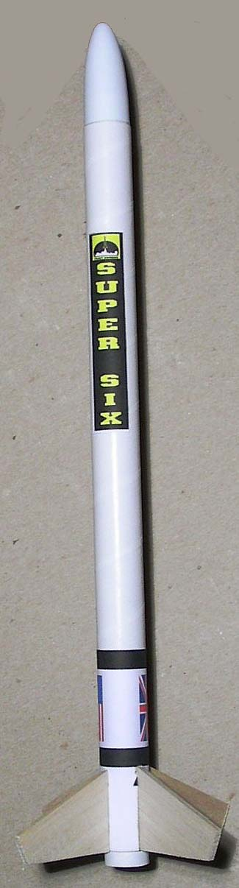
Super Six
Model Rocket Kit Instructions
Catalog number K-11
Pratt Hobbies, 2513 Iron Forge Road, Herndon, VA 22071
www.pratt-hobbies.com

PARTS LIST:
1 Body Tube (the longest and largest)
In Parts Bag:
1 Plastic Nose Cone
4 Precut Balsa Fins
1 Nose Cone Shoulder Tube (short white tube with a hole)
1 Motor Mount Tube (longer tube with a hole near one end)
1 Thrust Ring (thick cardboard ring)
1 Kevlar Shock Cord
2 Launch Lugs (smallest tubes)
1 HeatShield (Black felt square with a hole)
1 Plastic Streamer
1 Color Fin Wrap Sticker

Also needed: White (casein) or Yellow (aliphatic) glue, and 1/4 inch masking tape.

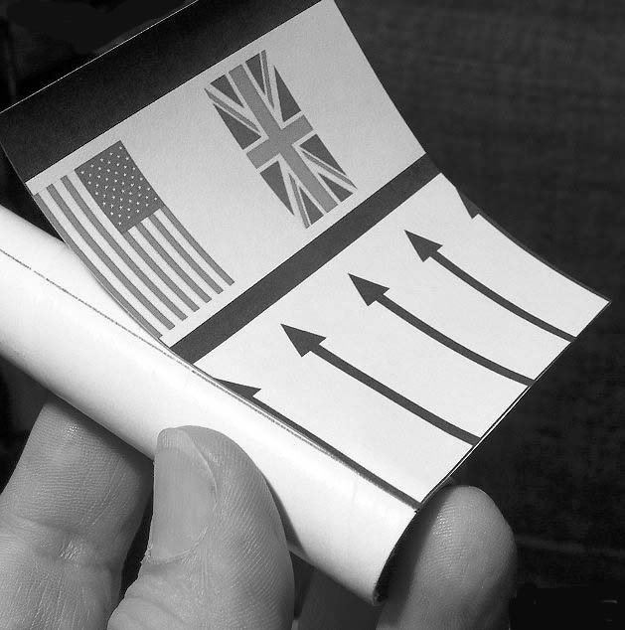
1. Open the Parts Bag. Check that all parts listed above are in the bag.

2. The Body Tube has a pencil mark drawn on one end. Use this mark to test-fit the Fin Wrap Sticker. Do not remove the backing paper from the sticker yet. Line up the sticker so that the arrows are pointing up, the bottom aligns with the bottom of the tube, and the left edge aligns with the pencil mark. Curl the sticker all the way around the tube. The thick stripes make it easier to see that the sticker is straight.

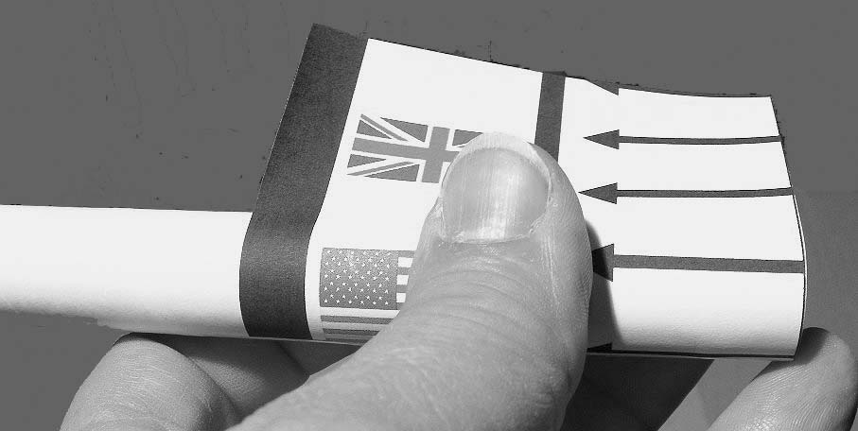
3. Peel the backing paper from the sticker. Line it up the way you did before, with the left edge of the sticker along the pencil line. Smooth the sticker down along the pencil line. If you need to, you can lift the sticker and re-position it. Working from the middle, use your thumb to roll down the sticker all the way around the tube. The adhesive on the sticker will allow you to lift and re-position it if you do it quickly.
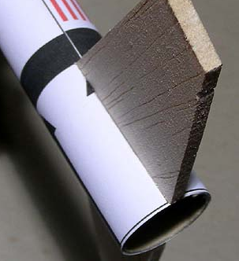

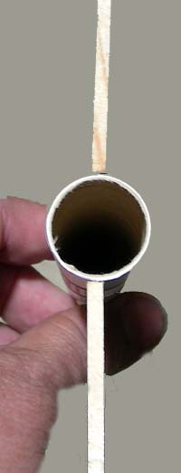
4. Place a line of white glue along the root edge of one fin. Rub the glue into the edge of the fin with your fingertip. A light coating of glue is best. Place the fin on one of the arrows on the Fin Wrap Sticker. The fin must be even with the rear of the tube and should cover the line of the arrow, with the tips of the arrow head visible on either side. Sight down the tube to make sure the fin is straight.

5. Apply glue to the root edge of another fin. Attach it to the arrow opposite the fin you glued on in step 4. Look down the back of the tube to make sure the fins are straight across from each other as shown here. Set this assembly aside to dry for about 5 minutes. It should stand up straight with the fins flat on the table.

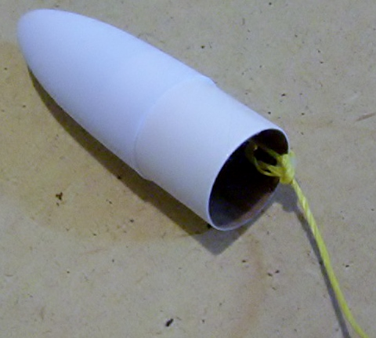
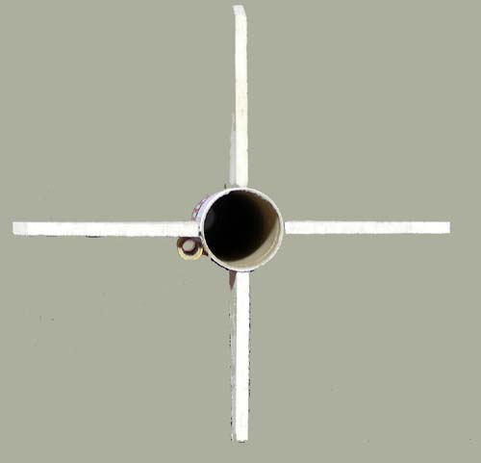
6. Check the Body Tube to make sure the fins are still straight. Apply glue to the root edge of a third fin and place it on one of the remaining arrows. Do the same with the fourth fin. Now sight down the back of the tube and make sure the fins form a cross. If you have to move a fin off center of one of the arrows to make the cross, do it. Your eye sighting down the back of the tube is the best method of aligning the fins properly. Set the assembly aside to dry. The fins should rest flat on the table.

7. Test fit the Nose Cone Shoulder Tube (short tube with a hole at one end) into the Nose Cone, inserting the end opposite the hole into the plastic Nose Cone. Remove the Shoulder Tube and run a line of glue around the inside edge of the Nose Cone. Insert the Shoulder Tube. Spread the glue around inside the nose cone with your finger. Tie the Kevlar Shock Cord through the hole in the Shoulder Tube. Move the knot so it is on the inside of the tube, and put a drop of glue on the knot.

8. Make a pencil mark ¼ inch from the end of the Motor Mount Tube that does not have a hole. Glue the Thrust Ring into the end of the Motor Mount Tube that has a hole. It should be flush with the edge of the Tube and not obstruct the hole.
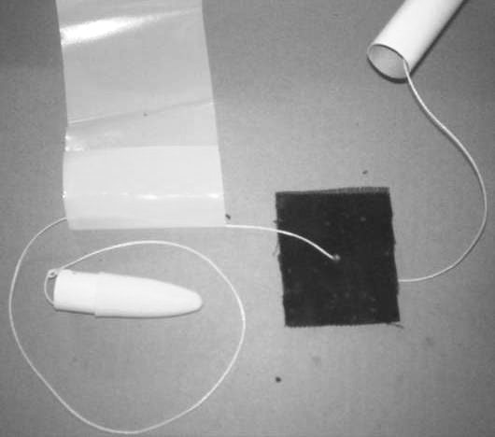
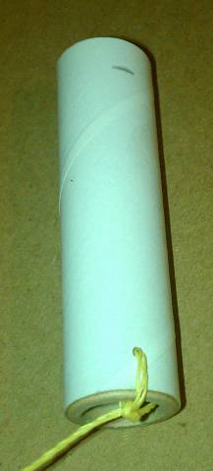
9. The Streamer has been folded and welded at one end to make a loop. Thread the Kevlar Shock Cord through this loop. Now thread the cord through the hole in the black felt HeatShield.

10. Check to see that the glue on the fins is dry and that the fins are firmly attached.

11. Push the free end of the Kevlar cord through the Body Tube from top to bottom. Fold the HeatShield and insert it in the Body Tube. It should make a plug that fills the tube. Fold and roll the Streamer into a neat package and use it to push the Heatshield down into the tube. Insert the Nose Cone.

12. Tie the Kevlar cord through the hole in the Motor Mount Tube, around the Thrust Ring. Position the knot above the Thrust Ring and put a drop of glue on the knot.

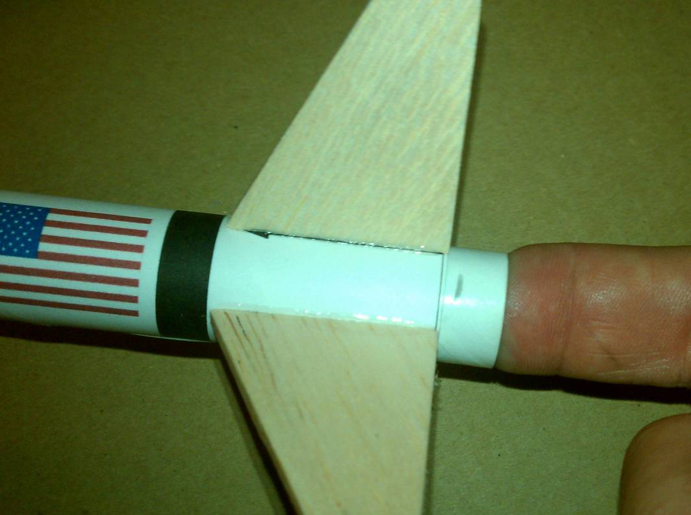
13. Test fit the Motor Mount Tube in the rear of the rocket. Remove the Motor Mount Tube, run a line of glue around the inside of the Body Tube, and re-insert the Motor Mount Tube up to the mark that you made in Step 8. ¼ inch of the Motor Mount Tube should stick out of the rear of the rocket. Insert the Motor Mount Tube in one smooth motion, turning it as you go, and don’t stop until you’re at the mark; the glue can grab if you stop, freezing the tube in the wrong position. Putting your finger in the Motor Mount tube is a good way to do this.
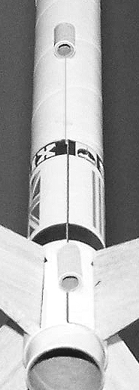
14. When the glue holding the fins is completely dry, run a thin line of glue along the side of each fin where it joins the body. Smooth this glue out with the tip of your finger so it forms an even fillet, touching both the fin and the tube. Allow the fillets to dry completely, checking to make sure the glue doesn't drip or form runs and the fins are still straight.

15. Glue one Launch Lug to the seam on the Fin Wrap Sticker. Use the pencil line on the Body Tube to line up the other launch lug and glue it in place. The second launch lug should be about halfway up the Body Tube. Make sure the launch lugs are straight and parallel with the Body Tube.

16. Once all the glue is dry, you can decorate your model. The Body Tube is coated in a special paper that accepts color markers well. Markers can also be used to color the fins. Do not use markers or paint on the nose cone, they may melt the thin plastic.

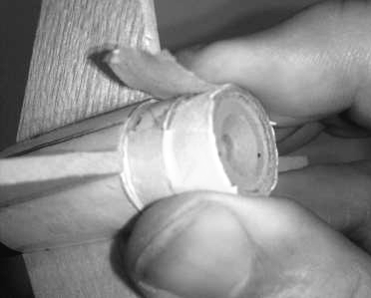
FLYING THE SUPER SIX
1. Insert the rocket motor into the Motor Mount Tube with the nozzle end out, until it is touching the Thrust Ring. A quarter inch of the motor will be sticking out of the rear of the Motor Mount Tube. Wrap one layer of masking tape around the tube and the motor to secure the rocket motor in the tube, as shown. Make sure the tape is stuck down tight. Oversize tape can be folded over the nozzle.

2. Insert the Heatshield and the Streamer as described in the instructions above. Follow the instructions that came with the motor to install the igniter in the rocket motor and launch the model.

DO NOT launch the model in winds of over 5 mph. DO NOT launch the model at an angle of greater than 20 degrees from the vertical. FOLLOW THE NAR SAFETY CODE. Visit the NAR Web site at www.nar.org, or write to National Association of Rocketry, PO Box 407, Marion, IA 52302.

Pratt Hobbies certifies that we have exercised reasonable care in the design and production of this product. Since we cannot control the use of the product after sale, the user assumes all risk and liability related to its use. This product is not intended for use by children under 13 years of age.

