
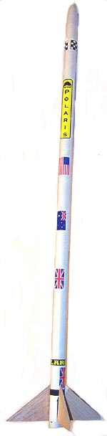
The Polaris
Model Rocket Kit Instructions
Catalog number K-22
Pratt Hobbies, 2513 Iron Forge Road, Herndon, VA 22071
www.pratt-hobbies.com

PARTS LIST:
- Main Body Tube (the longest and largest)

Bag 1: 1 Plastic Nose Cone
4 Precut Balsa Fins
1 Fin Wrap Sticker

Bag 2: 1 Nose Cone Shoulder Tube (the shortest tube, with a hole)
1 Motor Mount Tube (longer tube with a hole near one end)
1 Thrust Ring
1 Kevlar Shock Cord
2 Launch Lugs (tiny tubes)
1 HeatShield (thick felt square with a hole)
1 Plastic Streamer

Also needed: White (casein) glue. We recommend our Rocket Glue.

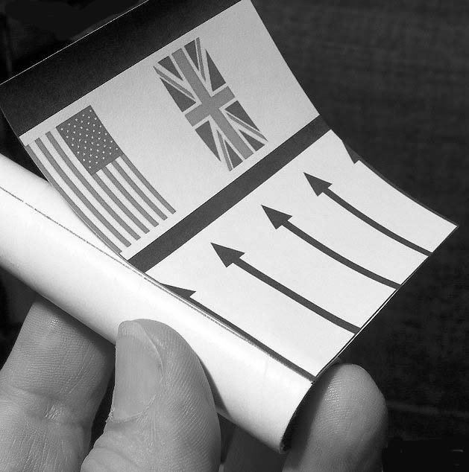
1. Open Bag 1. The Body Tube has a pencil mark drawn on one end. Use this mark to test-fit the Fin Wrap Sticker. Do not remove the backing paper from the sticker yet. Line up the sticker so that the arrows are pointing up, the bottom aligns with the bottom of the tube, and the left edge aligns with the pencil mark. Curl the sticker all the way around the tube. The thick stripes make it easier to see that the sticker is straight.

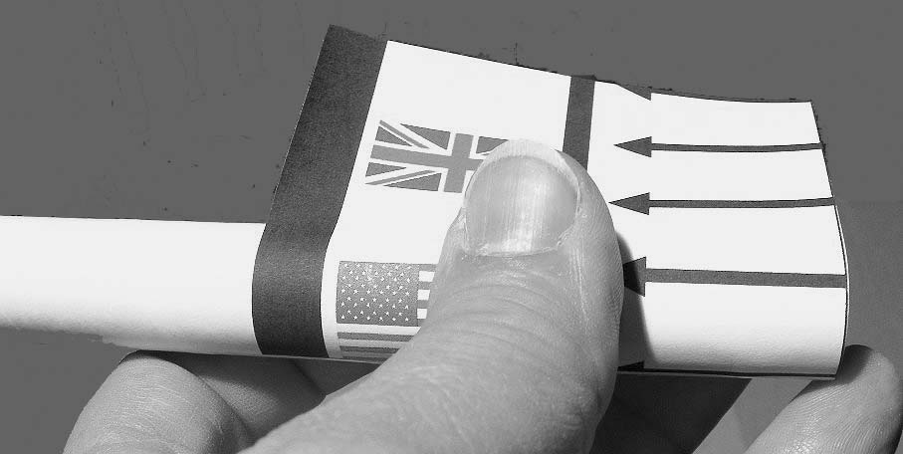
2. Peel the backing paper from the sticker. Line it up the way you did before, with the left edge of the sticker along the pencil line. Smooth the sticker down along the pencil line. If you need to, you can lift the sticker and re-position it. Working from the middle, use your thumb to roll down the sticker all the way around the tube. The adhesive on the sticker will allow you to lift and re-position it if you do it quickly.

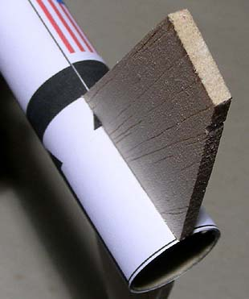
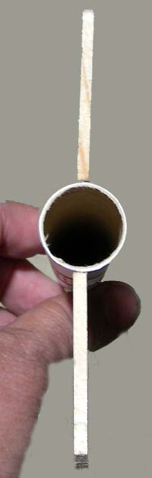
3. Look at one of the fins. They are triangular, with a 90 degree angle at the corner of the root edge and the trailing edge, so the body tube with the fins attached will sit flat on a tabletop. Another way to identify the edges of the fins is to look at the grain of the wood; it is parallel to the leading edge. The root edge is the edge that is glued to the tube; the leading edge is on top, and the trailing edge at the rear.
4. Place a line of white glue along the root edge of one fin. Rub the glue into the edge of the fin with your fingertip. A light coating of glue is best. Place the fin on one of the arrows on the Fin Wrap Sticker. The fin must be even with the rear of the tube and should cover the line of the arrow, with the tips of the arrow head visible on either side. Sight down the tube to make sure the fin is straight.

5. Apply glue to the root edge of another fin. Attach it to the arrow opposite the fin you glued on in step 4. Look down the back of the tube to make sure the fins are straight across from each other as shown. Attach the other two fins. Set this assembly aside to dry. It should stand up straight with the fins flat on the table.

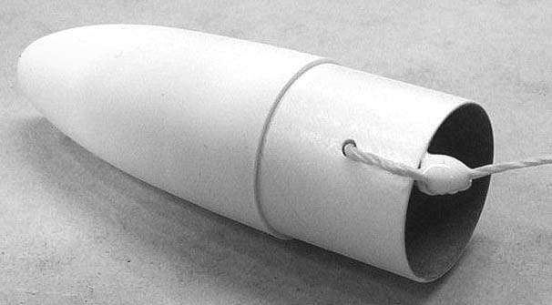
6. Open Bag 2. Run a line of glue around the inside of the Nose Cone and insert the Nose Cone Shoulder Tube, with the hole in the lower part of the tube uncovered.

7. Bring the end of the Kevlar Shock Cord up through the middle of the Nose Cone Shoulder Tube and tie it through the hole. Move the knot so that it’s on the inside of the tube and apply a small drop of glue to the knot.
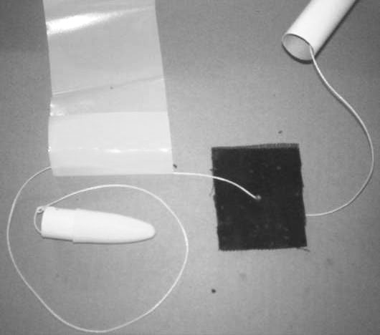
8. One end of the plastic Streamer has been folded over and welded to make a loop. Thread the Kevlar cord through this loop. Now thread the Kevlar cord through the hole in the black felt HeatShield.

9. Make a pencil mark ¼ inch from the end of the Motor Mount Tube that does not have a hole.
*-
10. Glue the Thrust Ring into the end of the Motor Mount Tube that has a hole. It should be flush with the edge of the Tube and not obstruct the hole.
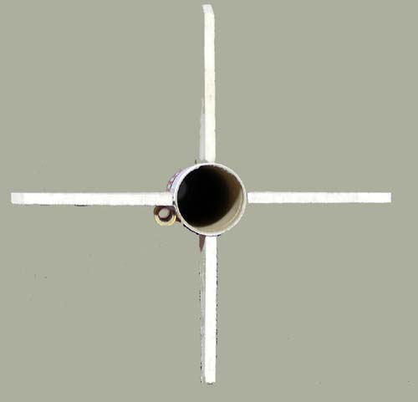
11. Check to see if the glue is dry on the fins. Check to be sure the fins are in a perfect cross, as seen from the rear.

12. Push the free end of the Kevlar cord through the Main Body Tube from top to bottom. Tie the end of the Kevlar cord that is coming out the bottom through the hole in the Motor Mount Tube and around the Thrust Ring. Position the knot so that it is above the Thrust Ring and put a small drop of glue on it.
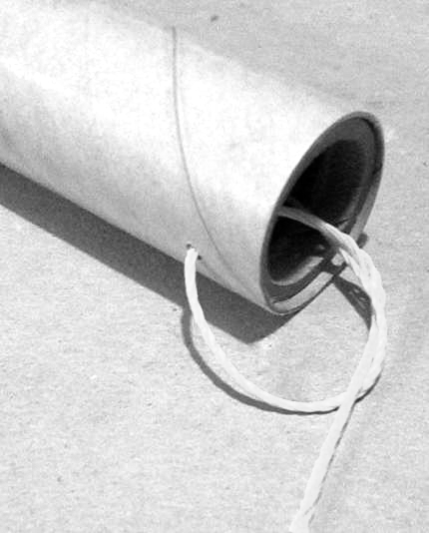
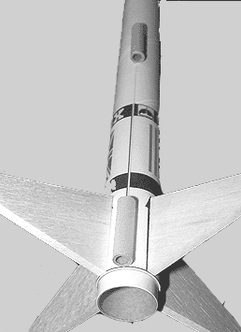
13. Test fit the Motor Mount Tube in the rear of the rocket. Remove the Motor Mount Tube, run a line of glue around the inside of the Main Body Tube, and re-insert the Motor Mount Tube up to the mark that you made in Step 9. ¼ inch of the Motor Mount Tube should stick out of the rear of the rocket. Insert the Motor Mount Tube in one smooth motion, and don’t stop until you’re at the mark; the glue can grab if you stop, freezing the tube in the wrong position.

14. Fold the felt HeatShield and insert it in the top of the Body Tube so that it forms a plug. Fold and roll the Streamer so that it fits into the Body Tube and use it to push the Heatshield down into the rocket. Wrap the excess Kevlar Shock Cord neatly and put it in the tube on top of the Streamer. Fit the Nose Cone into the top of the tube.

15. When the glue holding the fins is completely dry, run a thin line of glue along the side of each fin where it joins the main body. Smooth this glue out with the tip of your finger so it forms an even fillet, touching both the fin and the tube. Allow the fillets to dry with the rocket resting on its side and the fins off the edge of your table, checking to make sure the glue doesn't drip and the fins are still straight.

16. Glue one Launch Lug onto the seam of the Fin Wrap Sticker, even with the end of the Main Body Tube. Glue the other Launch Lug at the end of the pencil line, approximately halfway up the tube. Sight down the body to make sure the launch lugs are lined up perfectly straight.

17. Once all the glue is dry, you can decorate the Polaris. The body tube is coated with special paper that accepts washable markers. Markers can also be used to color the wood fins. Making one fin red and three fins black will give the Polaris an authentic “sounding rocket” look.

FLYING THE POLARIS
1. We recommend B and C motors for the Polaris. Our preferred motors are the B6-4 and C6-5 from Quest.
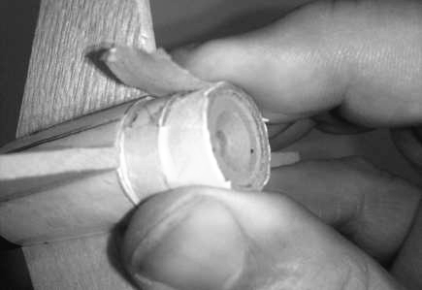
2. Insert the motor into the Motor Mount Tube with the nozzle end down. It will hit the Thrust Ring with about 1/4 inch of the motor still sticking out. Wrap one layer of masking tape around the Motor Mount Tube and the motor. This will keep the motor from ejecting out the back instead of popping the streamer out the front.

3. Follow the instructions that came with the motor to install the igniter and launch the model.

4. After each flight, remove the motor by unwrapping the masking tape. Insert the HeatShield and Streamer as described in Step 14 above. You do not need recovery wadding since the HeatShield protects the Streamer from the heat of the rocket motor’s ejection charge.

DO NOT launch the model in winds of over 5 mph. DO NOT launch the model at an angle of greater than 20 degrees from the vertical. FOLLOW THE NAR SAFETY CODE. For NAR information, call them at 800-262-4872, visit their Web site at www.nar.org, or write to National Association of Rocketry, 1311 Edgewood Drive. Altoona, WI 54720.

Pratt Hobbies certifies that we have exercised reasonable care in the design and production of this product. Since we cannot control the use of the product after sale, the user assumes all risk and liability related to its use. If you are dissatisfied with this product for any reason, we will replace it or refund the purchase price at our option. This product is not intended for sale or use by persons under the age of 13.

