
GO Box
Model Rocket Launch Control System
Instruction Manual
Pratt Hobbies
2513 Iron Forge Road
Herndon, VA 20171
www.pratt-hobbies.com

System Description

The GO Box is a simple, effective way of safely igniting model rocket motors electrically. As stated in the NAR Safety Code (www.nar.org), model rocket motors must always be ignited electrically from a safe distance. Never attempt to ignite a rocket motor with a fuse or match.

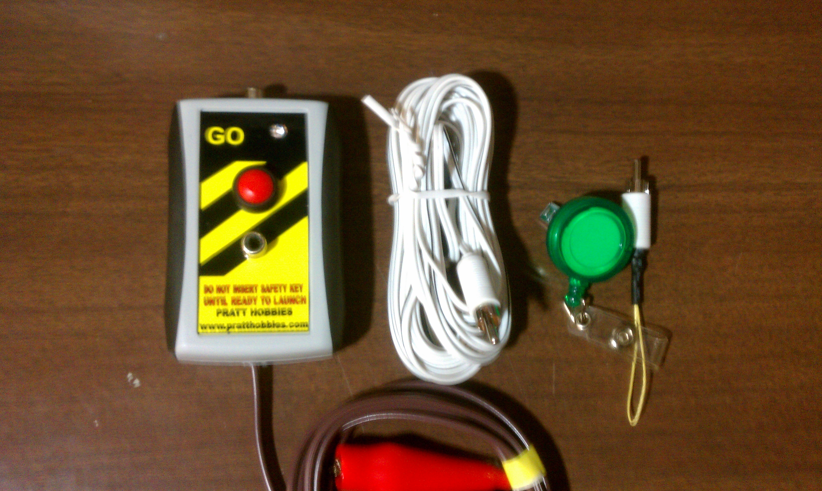
The GO Box consists of three parts: the control box, the safety key, and the ignition cable.

The control box is connected to a 12v power source. The ignition cable is laid out along the ground between the control box and the launch pad. 25 feet of ignition cable provides a safe distance between launch pad and spectators; other lengths are available. The safety key must be inserted in the control box for the system to operate, and is kept under control of the person responsible for the launch at all times.

When you are ready to launch, the safety key is plugged into the control box. A bright red light-emitting diode (LED) lights to indicate that there is a complete circuit through the igniter. When the launch button is pressed, full power goes to the igniter.

Control Box Ignition Cable Safety Key

Setting Up the GO Box

Your rocket launch pad (not supplied) should be set up in an area that is clear of trees and obstructions. Never fly near overhead power lines, or attempt to recover a model that is caught on power lines!

The GO Box control box has a power connector with an 8 foot wire lead. It is terminated in either a pair of battery clamps or a plug for a car cigar lighter. To use the lighter plug, your car should be wired so that the cigar lighter jack is center positive, as almost all American-made cars are.

. If your GO Box has battery clamps, connect the red clamp to the positive (+) terminal of a 12 volt battery, and the black clamp to the negative (-) terminal. Make sure the clamps cannot touch each other. If it has a cigar lighter plug, connect the GO Box power connector into your car cigar lighter and run the wire through a window so the control box is outside the car

The ignition cable has a male RCA pin plug on one end and micro clips on the other. To test the system, connect the clips together, then plug the other end of the cable into the control box. Now insert the safety key into its jack below the launch button. The LED will light, indicating a complete circuit through the clips. Unplug the safety key and keep it separate from the control box. Unplug the ignition cable.

Lay out the cable so that the clips are at your launch pad and the plug can reach the control box. Leave a little slack in the cable, so that if you accidentally pull on it you won't pull the igniter out of the model rocket motor.

Connecting to Motor Igniter

Before connecting the igniter, make sure that the safety key is NOT plugged into the control box. This insures that power cannot get to the igniter until you are ready to launch. For additional safety, you can leave the ignition cable unplugged from the control box until everyone is clear of the pad.

Read the instructions that came with the rocket motor to install the igniter in the motor.

If you require a different wire length, you can use audio-type extension cords with RCA Pin Plugs to connect between the igniter clips and the control box. We also sell a 25 foot extension cords. You can connect as many of these as you want, especially if you are using a car battery as your power source.

The clips on the ignition wire are easily connected to any model rocket igniter. Make sure that they do not touch each other or any other metal part.

Using the GO Box

When the igniter leads are connected to the clips, clear the launch area and return to the control box. Make sure everyone in the area is aware that you are about to launch a rocket. This is the best time to prevent accidents!

When you are ready to launch, plug the safety key into the control box. The LED will light, indicating that the circuit through the igniter is complete. Make sure all spectators are aware that you are ready to launch. Count down in a loud voice, and press the button at ignition. The LED will go out, and full power will be delivered to the igniter.

In the event of a misfire, do not approach the pad for at least 60 seconds. Immediately remove the safety key. After waiting 60 seconds, approach the pad and check the igniter. Most misfires are due to improper igniter installation. Follow the motor instructions carefully when preparing and installing igniters.

Care and Maintenance

Your GO Box should not require any maintenance. Coil the cords after each flying session, and clean the micro clips with a wet rag. If the clips wear out or become damaged, contact us for a replacement igniter wire.


We strongly recommend that you join the National Association of Rocketry (NAR). For over 55 years, the NAR has promoted hobby rocketry and worked to keep our sport safe and enjoyable. Your membership helps to support NAR programs as well as bringing you benefits like insurance coverage and an excellent magazine. We at Pratt Hobbies are proud to be lifelong members of the NAR. You can get complete information at their Web site, www.nar.org, or by writing to NAR, PO Box 407, Marion, IA 52302.

Warranty and Disclaimer

This product is guaranteed against defects in parts or assembly for 90 days from date of purchase. Contact us if you have any problems and we will arrange to have the product returned to us. We will repair or replace any defective parts or workmanship at our option.
Pratt Hobbies asserts that it has exercised reasonable caution in designing and manufacturing this product. As we have no control over our products once sold, we can take no liability for incidental damage that might occur when the product is used. It is the responsibility of the user to read this instruction manual thoroughly and understand the proper operation of this unit. This product must be used only as described in this manual. This product is not intended for use by children under the age of 13.

